–

VnV
Mini Project / PLP Document

Hotel Bookings Management System
(HBMS)

Document Control

Reference No:
Security Classification: | iGATE Internal
Issue Date:
Author(s): | Name |  | Title
Author(s): | Shrilata Tavargeri |  | Sr. Training Specialist
Reviewer(s): | Name |  | Title
Reviewer(s): | iLEARN Seniors Team |  | Sr. Faculty, Sr. Managers
Issuer(s): | Name |  | Title
Issuer(s): | Dinesh Anantwar |  | Sr. Manager
Issuer Signature(s):
Distribution: | Name |  | Title
Distribution: | iLEARN Team, PPPs |  | All Designations in iLEARN
Document History: | Date | Revision | Change
Document History: | Nov 22, 10 | 0.01D | Initial draft
Document History: | Nov 24, 10 | 0.02D | Review comments incorporated

Table of Contents
1 Introduction 4
1.1 Setup Checklist for Mini Project 4
1.2 Instructions 4
2 Problem Statement 5
2.1 Objective 5
2.2 Abstract of the project 5
2.3 Functional components of the project 5
2.4 Guidelines on the functionality to be TESTED: 6
2.5 Evaluation and assessment parameters: 11
2.5.1. Guidelines on the functionality 11
2.5.1. Evaluation Policy 12

Introduction

This document outlines a mini project for the V&V LOT. The project is to test an online Hotel Bookings Management System (HBMS) for a website “CheapStays.com”. This document contains the work flow of the system and gives guidelines on how to test the functionality gradually in each of the course modules of the V&V LOT.

Setup Checklist for Mini Project
Minimum System Requirements
- Intel Pentium 90 or higher (P166 recommended)
- Microsoft Windows 95, 98, or NT 4.0, 2k, XP.
- Memory: 32MB of RAM (64MB or more recommended)
- Internet Explorer 6.0 or higher
- MicroSoft Word and Excel 2003 or higher

Instructions
- The test cases should follow the test case standards.
- Create a directory by your name in drive D. In this directory, create a subdirectory MiniProject<Groupcode>. Store your Project here.Every document related to your mini project should be available in the same directory.
- You can refer to your course material.
- You have to follow the flow while doing the mini project, like Requirement Itemization -> Use cases -> Use case level test cases -> Form level test cases -> Filed level Test cases.

Problem Statement

Objective
Testing an online Hotel Bookings Management System (HBMS)

Abstract of the project
This project is aimed at testing an online Hotel Bookings Management System (HBMS). This is a web based application that can be accessed over the web. This system can be used to search for Hotel rooms and reserve them. This is an integrated system that contains both the user component, Hotel-Employee component and the Admin component.

Test the Application for the above requirement using the following Project link:

http://ndafile:8081/Spring_Hotel/login.html

Use following user credentials to access above given project link.

Username | Password | Role
admin | admin | Admin

Functional components of the project
Following is a list of functionalities of the system. Wherever, the description of functionality is not adequate; you can make appropriate assumptions and proceed.

There are three categories of people who would access the system viz. customer, hotel-employee & Admin. Each one of them would have some exclusive privileges (for e.g. customer and hotel-employee can just search for hotel rooms and reserve them, but only the admin has the right to add new and modify hotels.)

- Customer and Hotel-Employee should be able to

  - Register into the system.
  - Login to the system using his/her credentials.
  - Search for hotel rooms.
  - Book hotel rooms.
  - View Booking Status

- The Admin should be able to

  - Login to the system using his/her credentials
  - Perform Hotel Management (add/delete/modify Hotel info like description, any special offers etc)
  - Perform Room Management (add/delete/modify Room info like revised tariff)
  - Generate various reports like:
    - View List of Hotels
    - View Bookings of specific hotel
    - View guest list of specific hotel
    - View bookings for specified date

Guidelines on the functionality to be TESTED:
- Tables

- Refer the following tables, which were used in this application::
    - Users: This contains the list of valid users with details
    - Hotel: This will contain the list of hotels.
    - RoomDetails: This will contain the details of all the rooms available in all the hotels.
    - BookingDetails: This will contain the list of booked rooms and their details.
- The structure of the above listed tables is as follows:
    - Users: user_id(varchar(4)), password (varchar(7)), role(varchar(10), user_name(varchar (20)), mobile_no(varchar(10)), phone(varchar(10)), address (varchar(25)), email (varchar(15))
    - Hotel: hotel_id(varchar(4)), city (varchar(10)), hotel_name(varchar (20)), address(varchar(25)), description varchar(50)), avg_rate_per-night (number(m,n)), phone_no1(varchar(10)), phone_no2(varchar(10)), rating(varchar(4)), email (varchar(15)), fax (varchar(15))

Note : Description here could be a brief teaser about the hotel like – “Centrally located in the main city centre at Shivajinagar Railway Station, this budget accommodation is designed with spacious rooms…”. It could also give some special offers etc.

    - RoomDetails: hotel_id(varchar(4)), room_id (varchar(4)), room_no(varchar(3)), room_type(varchar(20)), per_night_rate (number(6,2)), availability (Boolean), photo (blob))

Note : Room_type could be Standard non A/C room, Standard A/C room, Executive A/C room, Deluxe A/C room etc.

    - BookingDetails: booking_id(varchar(4)), room_id(varchar(4)), user_id(varchar(4)), booked_from (date), booked_to(date), no_of_adults, no_of_children, amount(number(6,2))

The functionality and components to be tested :

- Application

- Requirement for the application:
- Home page screen: Home page for the online HBMS which provides a link for the login page.

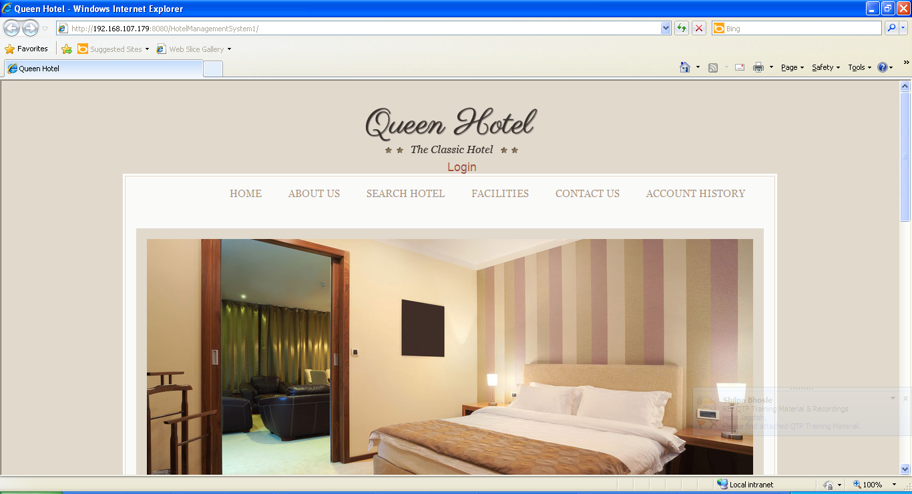

- Login Screen: Allows the valid user or amount to logon to the system and display the Main option screen.

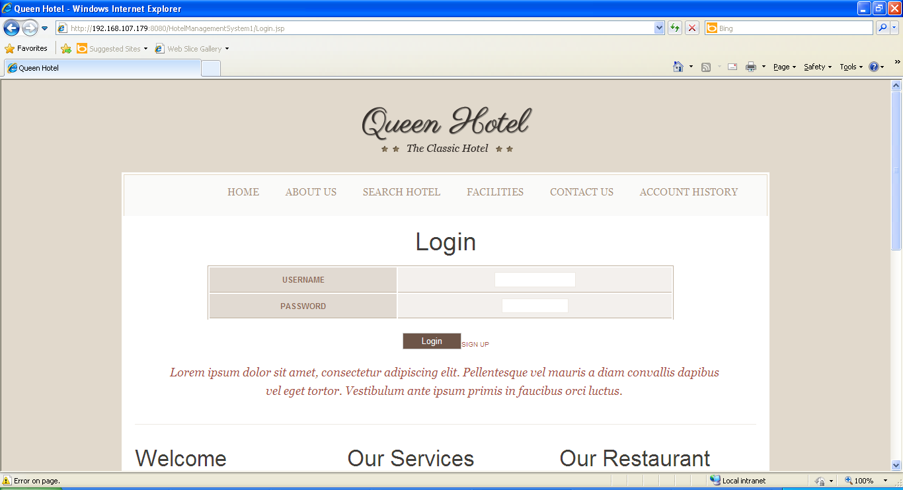

- View Hotel screen: For all the users, this screen shows a list of hotels and rooms.

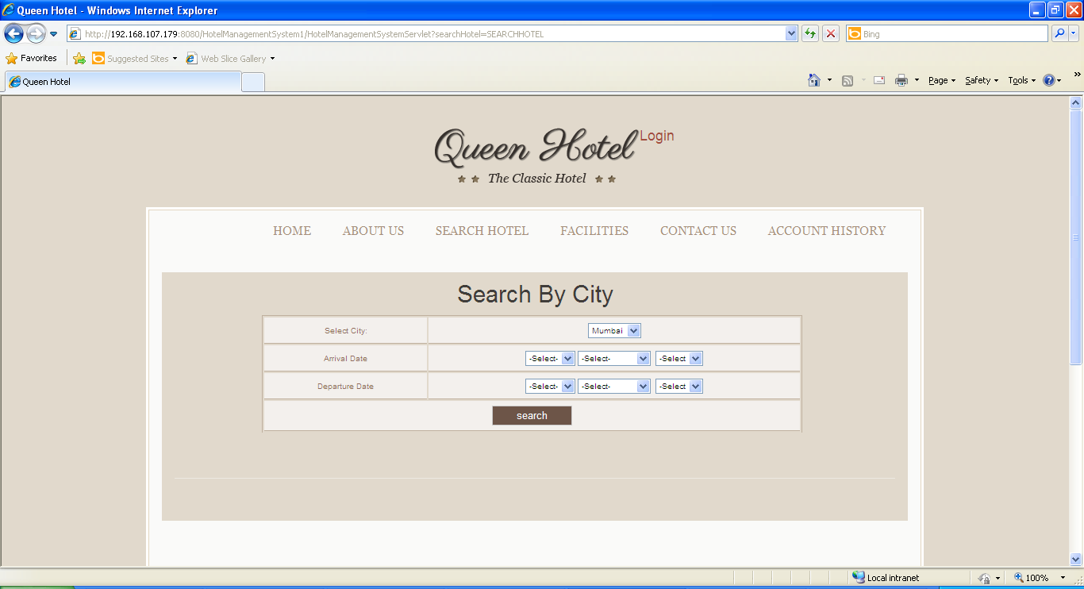
- Book Rooms: For the customers and the hotel-employees, this screen will allow booking of available hotel rooms.

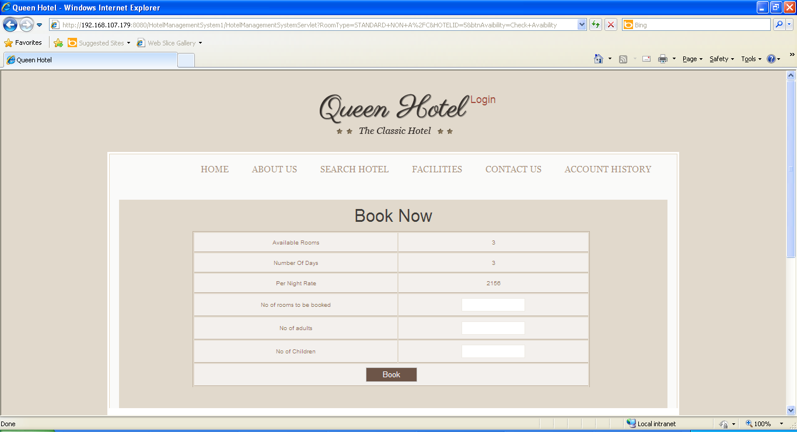

- Add Hotels: This screen allows the admin to add new hotels or rooms.

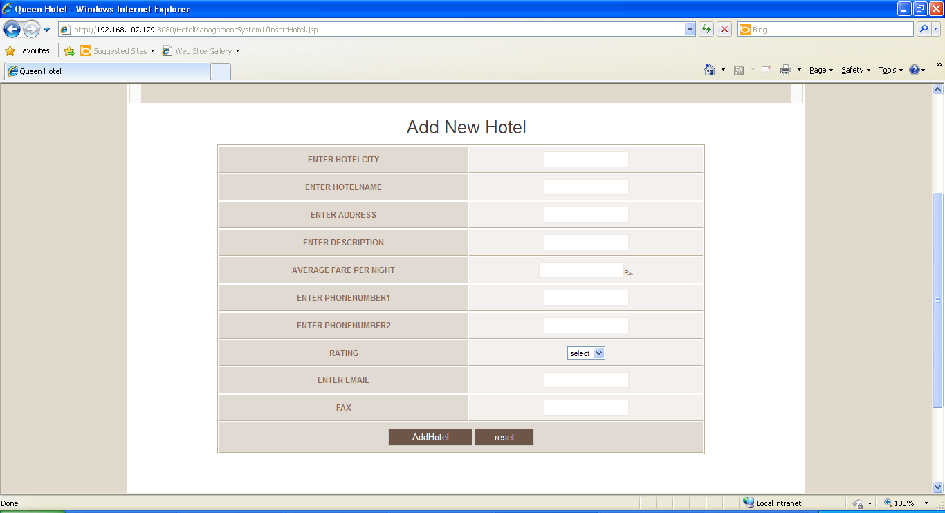
- Update Hotels: This screen allows the admin to update existing hotels or rooms.

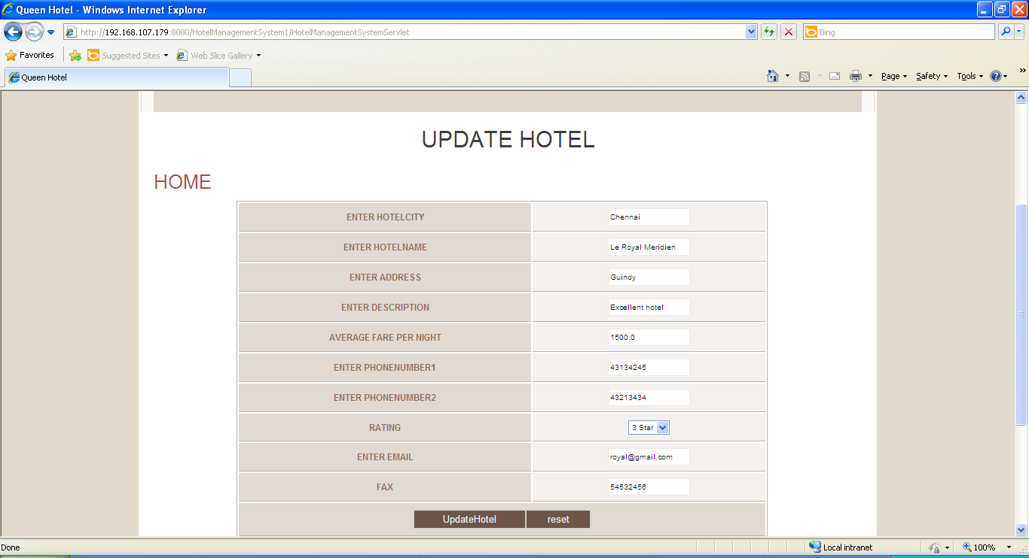

- Delete Hotels: This screen allows the admin to delete existing hotels or rooms.
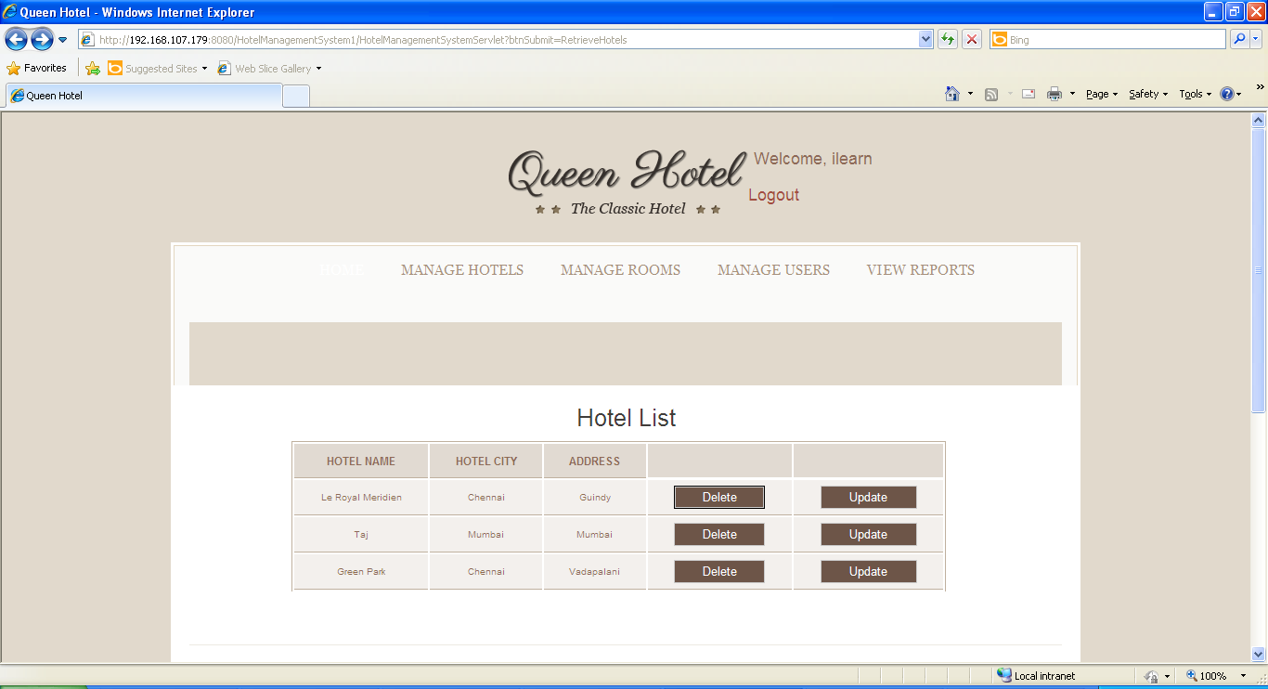

- View Reports: This screen offers administrator to view various reports by clicking on an appropriate link.
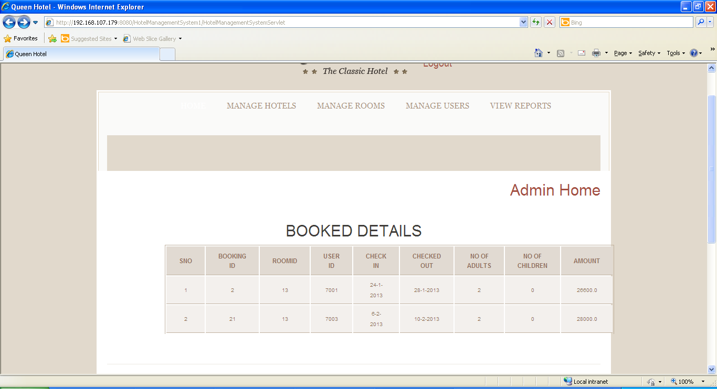

- Test all other screens and links that appear in the application for admin, Employee and Customer.

- Test the business components for the following functionality:
- User verification: (on Login) This component will verify if the user who is trying to access the system is a valid user. This verification is as against the valid users listed in the users table.
- Add/Delete/Modify: This component will allow the admin to add new hotels, update and delete existing hotels.
- Book Rooms: this component will allow the customers to book rooms.

Evaluation and assessment parameters:
The participants need to do Requirement Itemization and to develop Use case, Scenario matrix and test cases for the Hotel Bookings Management System using TBA template and defect report while test execution.

Guidelines on the functionality
Form a group of 5 people. One person will be group leader will divide the work among the group members.

Evaluation Policy
Sr. No | Marks | Project Execution
 | 100 | Evaluation shall be done after the DFDR course is over. Participants shall submit the sheet along with V&V DFDR assignments.

Following points will be considered for giving marks:

Sr. No | Points to be considered | Marks
 | Writing test cases in appropriate sheets. | 30
 | Defect report creation | 20
 | Proper and concise explanation of test cases and Input data | 30
 | Format of the sheet | 10
 | Complete solution | 10

